## **Bulletin Two**

## **“Sultan of Slalom”**

You are receiving this bulletin as you have submitted an entry to compete in the “Sultan of Slalom” 3 round slalom waterski competition and have either been accepted (subject to payment) or you are on the Waiting List.

***Added 31st May -*** If payment has been received your entry is confirmed and you will receive an email via EMS in the next few days

***Added 31st May -*** If you have not yet paid please note that as of 1st June the entry fee increases to £120.

**Date**: Saturday 27th July 2024

**Start Time**: 08:30

**Location:** Cirencester Waterski Club – Lake 37 Spine Road West, Cirencester – see *Figure 1 Location - Lake 37 Cirencester Waterski Club below*

**Pricing:**

The price you pay will be dependent on when your payment is received**:**

***Early Bird discount option: Payment received before Saturday 1st June - £105 - No longer available***

***Standard:*** Payment received between **1st June** and 15th July (incl) **- £120**

***Late Payment:*** Payment received after closing date (15th July) **- £135**

**NOTE: The competition is fully subscribed and has a waiting list of competitors, any entrants who have not made full payment by Friday 19th July may find their entry revoked.**

**NOTE: If you are unable to attend the competition please advise the organiser as soon as possible, as this will allow your place to be reallocated to the next person on the waiting list.**

**Payment details:**

Payment is to be made direct to Cirencester Waterski Club bank account (details below):

Please ensure you add the reference “2024 Comp entry” to your payment reference to ensure competition payments are easily identifiable.

Bank Account Name: Cirencester Water Ski Club

Sort Code: 30–94–80

Bank Account No: 00725318

***No other form of payment will be accepted for competition entry.***

**Practice:**

15-minute practice slots may be booked for Friday 26th July subject to availability on a “first come first served” option.

A one-off payment of £10 must be paid to cover temporary member (TM) insurance for the practice day prior to running a pass.

The cost of each practice set is £20, i.e.

Initial practice set = £10 (TM) plus £20 =£30

2nd practice set = £20

Payment for any practice sets (incl Temp membership) is to be made **in cash on the day.**

***Added 31st May -* Hotels:**

We have struck a deal with a local hotel [Cricklade House Hotel & Spa](https://www.crickladehotel.co.uk/) for a B&B rate of £120 per night for the Friday and Saturday nights.

To book contact the hotel directly 01793 751767 to book quoting the reference “Sultan of Slalom”. Availability of rooms is limited.

Other hotels in the area that are within a short drive to the lake and can be booked are:

[Travelodge](https://www.travelodge.co.uk/) - Cirencester

[De Vere Cotswold Water Park](https://www.devere.co.uk/cotswold-water-park-hotel/?utm_source=google&utm_medium=local&utm_campaign=localSEO)

**Overnight stay on site:**

There is a limited number of Motorhome, Caravan, and Tent pitches available for overnight stays on both Friday and Saturday nights:

Motorhome/Caravan: £10 per night

Tent: £5 per night

***Added 31st May -*** Should you wish to stay on-site overnight please email the organiser ([peterhogben00@gmail.com](mailto:peterhogben00@gmail.com)) directly to book your slot .

**Competition T Shirts:**

Competitors will receive a “T” shirt as a memento of the day, unless also covering an official’s position, in which case they will receive a Polo Shirt.

***Added 31st May -*** Competitors are requested to provide the size of T Shirt they would like to receive by emailing [peterhogben00@gmail.com](mailto:peterhogben00@gmail.com) direct

**Food:** Located on the Start/Exit Doc -see *Figure 2 Site Layout - Cirencester Waterski Club* below

Teas, coffees, soft drinks, snacks, and cake available all day

Breakfast BBQ (Bacon/ Sausage/ Egg Baps) from 08:15

Lunch BBQ (Hot Dogs, Burgers) from 12:00

**Changing & Shower Facilities:**

Male and Female changing room and showers are available in the Clubhouse.

Single changing room is available on the start dock. see *Figure 2 Site Layout - Cirencester Waterski Club* map below.

**Toilets:**

Full toilet, shower and changing facilities are available in the clubhouse.

Portaloo’s are available on the bund close to the judging tower and also on the landward side of the walkway bridge. see *Figure 2 Site Layout - Cirencester Waterski Club* map below.

**Parking:**

On site parking is available - see *Figure 2 Site Layout - Cirencester Waterski Club* map below.



**Figure 1 Location - Lake 37 Cirencester Waterski Club**

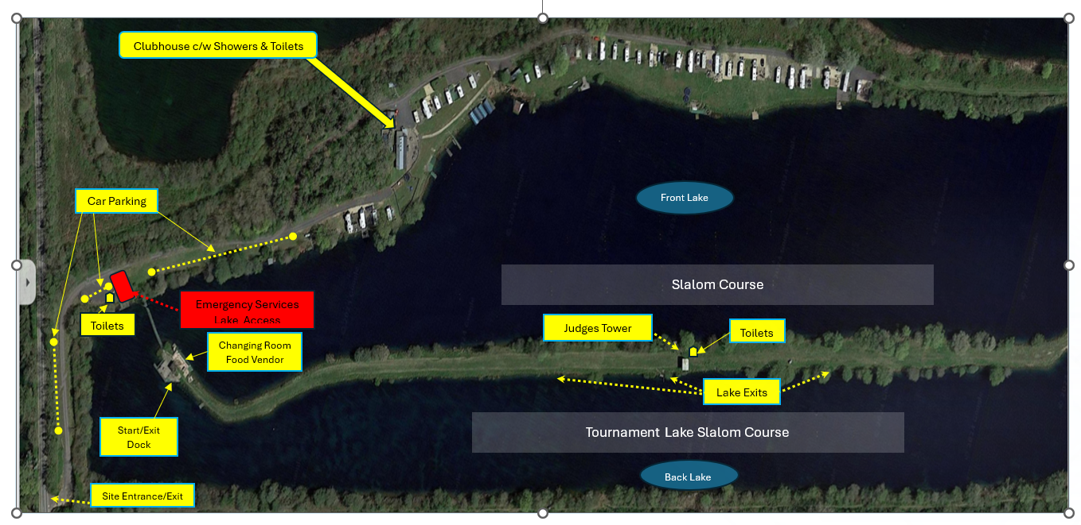

**Figure 2 Site Layout - Cirencester Waterski Club**