2023 British National Youth Festival
sponsored by
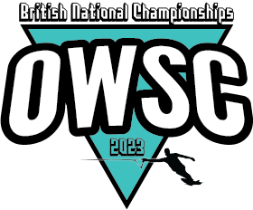
Friends of Tournament
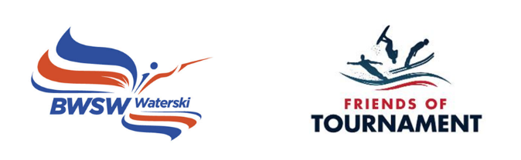

Bulletin - British National Youth Festival 25th August 2023

Oxford Water Ski Club, Queenford Lakes, Burcot Lane, Dorchester, Wallingford OX10 7PQ
Skier Briefing 8.00. Skiing Commences 8.30 and scheduled finish 17.30.

Points of contact on the day:
Dush Lukic 07587 554763 – dushylukic@hotmail.com and
OWSC Clubhouse 07974 369982 – bookings@owsc.com .

Please download the attached booking form, complete, and send to Kylie Cooper: kylie@bwsf.co.uk . Instructions for payment are included in the booking form.
Closing Date for entries 9th August 2023.

Entry Criteria - U18 D-Day Participants and those grass roots skiers not slaloming in actual National Championships
Skiing Disciplines – Slalom Only
Rules – will replicate the Cotswold Series grass roots rules - 4 passes in round one and then eliminator in round 2.
Age & Skier Categories - As above and includes a Novice Category for non-slalom course skiers.
Cost - £20
Licence Requirements - None
Facilities/Activities/Events – Camping/Aqua Park/Football Nets and Beach Volleyball – Pro night slalom on Saturday 26th August

Host Club OWSC: Steve Glanfield
Organisers: Dush Lukic & FoT
Facilities: Camping and on-site catering facilities are available as part of the British National Championships facilities that weekend.
Camping: Contact Steve Glanfield

The National Youth Festival and FoT Development Days are organised by volunteers and funded by sponsors. Friends of Tournament rely entirely on fund raising, our main initiative is ‘The 200 Club’, a small lottery. The details of this can be found on our website: http://www.tournamentwaterskiing.org.uk/200-club/

