TJ DELFÍN OLEKSOVICE

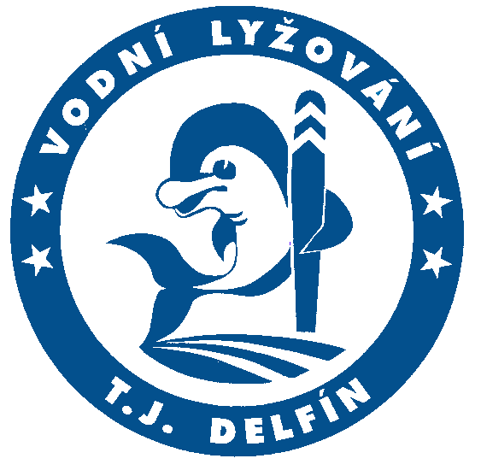

INTERNATIONAL WATERSKI COMPETITION
MORAVIA CUP 2024
39th Annual
BULLETIN

Organizer: TJ DelfÍn Oleksovice – Waterski Club

Competition area: Waterski Center Delfín – Oleksovice,
Znojmo District, Czech Republic

Date of competition: June 15-16, 2024

The competition is announced according to the following categories and disciplines:

Dauphines Tricks, Slalom, Jumping
Combination of all three disciplines
Juniors Tricks, Slalom, Jumping
Combination of all three disciplines
Open Men and Women Tricks, Slalom, Jumping
Combination of all three disciplines
+35, +45, +55 (together) slalom
Categories will be separately evaluated only when the number of competitors will be 5 or more than 5.

Conditions of participation: Valid booking of participants via EMS – IWWF.
for competition up to 7th June 2024.
Valid international certificate of
sport-accident insurance.
The trick list will be required.
Booking address: Zdeněk Nečas, Pšeník 3, 639 00 Brno, Czech Republic
or by E-mail : necas.zdenek@volny.cz

Cost: Each competitor has to pay the charges for each discipline 700,- Kč (30 €)
All 3 discipline 2.100,-Kč (90 €) at the moment of personal booking at the booking office in Waterski Center Oleksovice on Friday 14th June 2024 up to 7:30 p.m.

Accommodation:
Accommodation at other facilities is necessary to order directly by phone:
Hotel Horse Farm, 671 63 Lechovice, tel.: +420 515 271 438, info@horsefarmlechovice.cz
Motel Hostěradice, 671 71 Hostěradice, tel.: +420 723 724 350,

Board: The canteen in our sport center will be opened during the whole competition. Refreshment, hot meals and cold drinks will be available there.

Training: Unofficial free training: Friday 14th June 2024, from 9.00 a.m. till 7.00 p.m.
Charge 35 CZK per minute. You must order the required time for training in writing. Send this requirement together with application form in given term. You will be informed about your training time till 14th June 2024.

Towboats: SKI-NAUTIQUE equipped with ZERO OFF

Combination: The first three winning men and women in combination will be awarded prices – Cups.

The first three competitors in dauphine and junior category will obtain a medal as the first, second and third price.

Program:

14th June 2024 9:00 a.m. to 5:00 p.m. Arrival, booking,
9:00 a.m. to 7:00 p.m. unofficial free training,
7:30 p.m. heads and leaders of delegations conference,
drawing lots,
8:00 p.m. judges conference,

15st June 2024 8:00 a.m. preliminary round: slalom,
11:00 a.m. preliminary round: jumps,
2:00 p.m. second round: jumps
5:30 p.m. preliminary round: tricks,

16nd June 2024 8:00 a.m. second round: slalom,
11:00 a.m. second round: tricks,
5:00 p.m. Moravia Cup evaluation and price award.

Organizer reserves the right to realize changes in defined program due to unfavorable weather conditions or with respect to the number of presented competitors.

The homologation of the competition is according to standing list.

Director of competition: Mr. Robert Válek

Secretary of competition: Mrs. Jindřiška Žihlová

Zdeněk Nečas
TJ Delfín Oleksovice

Prior to the competition every skier takes the following indemnity into account:

Standards for condition and safety measures of tournament site are suited to the respectively valid rules of the International Waterski Federation (IWWF), the Czech Waterski and Wakeboard Federation (CWWF), the respectively valid rules and way of holding of the CWWF and the respectively valid agreement (rule book) between the organizing committee (OK) and the CWWF. Orders of the respective judge are so far definitive. Each participant commits himself to tell own faulting the judge. Starting in the tournament means that the competitor will recognize the suitability and sufficiency of the given tournament site condition and the available safety measures. The promoter will accept no moreover responsibility for a certain tournament site condition or special safety measures.
As a competitor in the Moravia Cup 2024 I agree:
- to comply with all instructions given by the IWWF/E&A officials and the organiser;
- that I take part in or am involved in the competition at my own risk;
- that neither the IWWF/E&A nor the organiser nor their officers, servants or agents are responsible for the loss of or damage to personal property, sports clothing or equipment howsoever such loss or damage arises; and that neither the IWWF/E&A nor the organiser nor their officers, servants or agents are responsible or liable for any injury or death caused to or suffered by me in any accident, fatal or otherwise, howsoever caused and whether occuring during or in connection with the competition.

