British National Youth Festival
Hazelwoods Ski World 28th – 29th August August 2024
BOOKING FORM
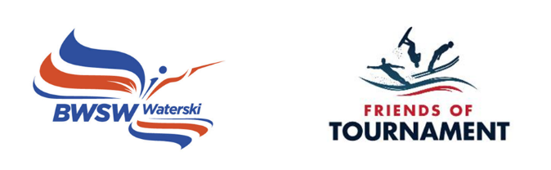
Skier Name |  | Surname
DOB |  | Gender
Club |  | Coach
BWSW membership |  | Address
Emergency contact |  | Relationship to skier
Emergency telephone |  | Email

Please make us aware of any relevant medical information/allergies.

Slalom Personal Best in Practice

Slalom Personal Best in Grass Roots Events

Please confirm that you are happy to be contacted by email: Y/N
Please confirm that you are happy for photos of your child to be shared on social media: Y/N

Please download and send to Kylie Cooper kylie@bwsf.co.uk.
Closing date for entries 15th August 2024

Payment: The cost of the event is £20.00 to be paid to BWSW Friends of Tournament.
Account Name: British Waterski & Wakeboard Federation Limited
Sort Code: 30 84 23 Account Number: 25491760 Reference: surname/ event code

Signed by parent/guardian:
Print:
Date:

