2024 British National Youth Festival
sponsored by:
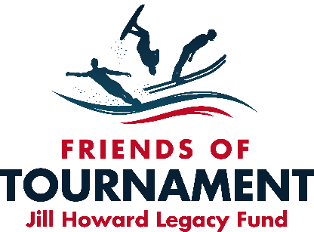

Bulletin 1 - British National Youth Festival 28th – 29th August 2024

Following the success of our first Youth Festival in 2023 the event is again being integrated into the Combined National Championships. This year the event will take place over two days. The afternoon of the 28th and morning of the 29th August.

Hazelwoods Ski World, Moor Lane, Lincoln, LN69BW
28th August - Skier Briefing 11.00. Skiing commences 12.30
29th August – Skier Briefing 08.00. Skiing commences 08.30

Points of contact on the day:
Dush Lukic 07587 554763 – dushylukic@hotmail.com
Catherine Wharton 07896 043419 – cagnpaul@gmail.com

Please download the booking form from EMS, complete, and send to Kylie Cooper: kylie@bwsf.co.uk . Instructions for payment are included in the booking form.
Closing Date for entries 15th August 2024.

Entry Criteria - U18 D-Day Participants and those grass roots skiers not slaloming in actual National Championships
Skiing Disciplines – Slalom Only
Rules – will replicate the Cotswold Series grass roots rules - 4 passes in round one and then eliminator in round 2.
Age & Skier Categories - As above and includes a Novice Category for non-slalom course skiers.
Cost - £20
Licence Requirements - None
Facilities/Activities/Events – Camping/Aqua Park/Backlake Training sessions

Host Club : Hazelwoods Ski World
Organisers: Dush Lukic & FoT
Facilities: Camping and on-site catering facilities are available as part of the British National Championships facilities that weekend.
Camping - £10 : Contact : 07917 275448

Hotels in the locality
Ibis 01522 698333 Family Rooms 2 miles
Damon’s 01522 887733 Mini Pool and good Food 2 miles
Bentley 01522 878000 Best Western Chain 1 mile
Railway 01522 681499 Bed and Breakfast 1 Mile
Thorpe Park Cabins 0800 6212777
Travel Lodge Thorpe on the Hill 08719 846085 1 Mile

The National Youth Festival and FoT Development Days are organised by volunteers and funded by sponsors. Friends of Tournament rely entirely on fund raising, our main initiative is ‘The 200 Club’, a small lottery. The details of this can be found on our website: http://www.tournamentwaterskiing.org.uk/200-club/

