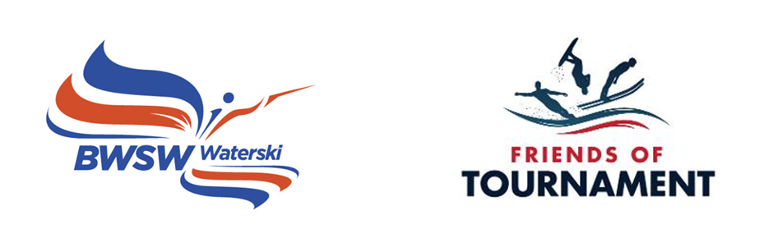
2023 Squad Days
sponsored by
Friends of Tournament

Bulletin 1

31st July / 1st August 2023 Skiers briefing at 08:30, ready to ski at 09:00. Aim to finish at 17:00.
Hazelwood Ski World, Moor Lane, Lincoln, LN6 9BW

Point of contact on the day: Charlotte Wharton. Email: charlotte.pwtc@gmail.com

The purpose of the two days is for GB Squad members to utilise this time and coaching to improve, learn and develop. It also allows time with fellow squad members and the opportunity to meet with others with Tournament knowledge. Parents are most welcome!

Preparation:
We ask that all skiers think about what you would like to achieve on the day as well as your previous scores and goals going forward. Be prepared to discuss this with the coach and selectors.

Coach: Charlotte Wharton

Facilities: Changing rooms and toilets

Food: Café on site

Camping: Camping available upon request. Please contact charlotte.pwtc@gmail.com if needed.

Open to all U14/U17U21 Squad members. Please register on the EMS event where you will go onto the wating list pending final approval.

Squad Days are organised by volunteers and funded by sponsors. Friends of Tournament rely entirely on fund raising, our main initiative is The 200 Club, a small lottery. The details of this can be found on our website: http://www.tournamentwaterskiing.org.uk/200-club/

