2023 Development Days
sponsored by
Friends of Tournament & Midlands Nautique
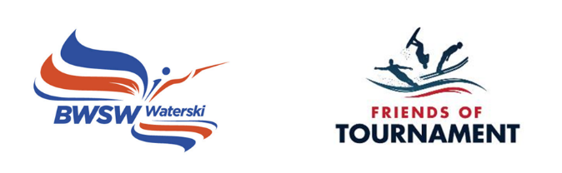

Bulletin D-Day 2
Tuesday 8th August 2023. Skier briefing at 08:30, ready to ski at 09:00. Finish at 17:00.

Oxford Water Ski Club, Queenford Lakes, Burcot Lane, Dorchester, Wallingford OX10 7PQ

Point of contact on the day: Steve Glanfield 07979 520083 steve_glanfield@yahoo.co.uk

Please download the booking form, complete, and send to: dushylukic@hotmail.com Instructions for payment are included in the booking form.

The purpose of the day is to provide coaching to U18 Club level water skiers who would like to progress to three event skiing. It is hoped that each skier will have 4 ‘coaching sets’ lasting approximately 15 to 20 minutes each. For anyone who has not previously held a BWSW Tournament Licence, this will be issued virtually after the event. We cannot provide coaching for disciplines outside of Tournament Water Skiing and places are not available for GB Squad skiers.

Friends of Tournament will organise a qualified BWSW Coach and an off-water Ambassador for advice on equipment and competitive skiing generally. The Ambassador will liaise with you prior to the day regarding the boat and any other arrangements.

Coach: Steve Glanfield
Ambassador: Dush Lukic
Facilities: showers/ changing/ indoor/outdoor space
Food: food provided for skiers and food available to buy for parents carers
Camping: Contact Steve Glanfield

Development Days are organised by volunteers and funded by sponsors. Friends of Tournament rely entirely on fund raising, our main initiative is ‘The 200 Club’, a small lottery. The details of this can be found on our website: http://www.tournamentwaterskiing.org.uk/200-club/

