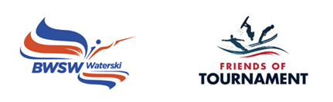
2024 Development Days
organised by
Friends of Tournament
Supported by Eddie Stobart Ltd & Midlands Nautique

Bulletin - Lound WSC - 29th May 2024

Wednesday 29th May 2024. Skiers briefing at 08:30. Ready to ski at 09:00. Finish at 17:00.
Lound WSC - Chainbridge Ln, Retford, DN22 8RU

Point of contact on the day: Marc Grinhaff
Please download the booking form, complete, and send to: mgrinhaff@yahoo.com and copy to dushylukic@hotmail.com - Instructions for payment are included in the booking form.

The purpose of the day is to provide coaching to U18 Club level water skiers who would like to progress to three event skiing. It is hoped that each skier will have 4 ‘coaching sets’ lasting approximately 15 to 20 minutes each. For anyone who has not previously held a BWSW Tournament Licence, this will be issued virtually after the event. We cannot provide coaching for disciplines outside of Waterski and places are not available for GB Squad skiers.

Friends of Tournament will organise a qualified BWSW Coach and an off-water Ambassador for advice on equipment and competitive skiing generally. The Ambassador will liaise with you prior to the day regarding the boat and any other arrangements.

Coach: Glenn Campbell
FoT Ambassador: Dush Lukic
Facilities: showers/ changing/ indoor/outdoor space
Food: provided for skiers
Camping: Contact: Marc Grinhaff
Event code: Lound24

Development Days are organised by volunteers and funded by sponsors. Friends of Tournament rely entirely on fund raising, our main initiative is ‘The 200 Club’, a small lottery. The details of this can be found on our website: http://www.tournamentwaterskiing.org.uk/200-club/

