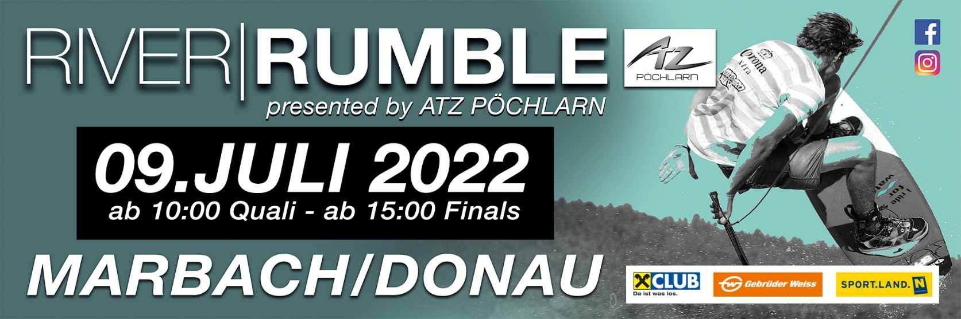

In order and with permission of the Austrian Waterski and Wakeboard Federation (ÖWWV), the Austrian Federal Sports Organization (BSO) and the International Waterski and Wakeboard Federation (IWWF), the Watersports club Marbach/D invites you to the 1st Boat Event of the Austrian Wakeboard Cup 2022.

At the same time, the 1st tour stop will take place in Marbach/D as part of the "Danube Wakeboard Masters 2022" for Lower Austria.

Place: Donaustraße 35A, 3671 Marbach/D.

Responsible club: WSC Marbach/D, Section Waterski/Wakeboard
Internet: www.wakesharks.at
Contact: Helmut Nagl 0664/6170321

Rules: The competition will be held according to the international rules of the
Region EAME and the Additional Austrian Rules, in freeride mode
discharged. From time saving and fairness becomes for every class,
except Open, only one dumbbell with rope used.

Categories: Boys / Girls: Year of Birth 2008 or later
Junior Men / Ladies: Year of Birth 2007 - 2006 - 2005 - 2004
Amateur: Rookie and Intermediate !! 1 Invert/Pass !!
Open Ladies For any, open class without restrictions
Open Men: For any, open class without restrictions
Masters: Year of Birth 1992 or older

(Minimum Number per Class 3 Starters)

Qualification: The event is free for all national and international athletes. All
participants will also be in the Austrian Wakeboard Cup and Danube
Wakeboard Masters overall standings 2022

Judging: Chief Judge Sabastian Baldia

Official Tow Boat: Mastercraft X22

Driver: Chief driver Simon “Smove” Kuntner

Registration: Registration takes place on site. Regular entry deadline is Friday,
July 8th, 2022 at 4 p.m..

Entry fee: Boys/Girls, Junior Men, Junior Ladies € 40,00.—
Amateur, Open Men, Open Ladies, Masters € 45,00.—
Late registration € 50,00.—

The entry fee includes:

- Accreditation card
- 1 Training ride Friday (5 min)
- Competition ride(s) Saturday
- 3 beverage vouchers

Training: On Friday each rider is available between 9 a.m. and 7 p.m 5 minute
workout available. All other training minutes (à 2.00 EUR/min) can be
arranged individually. All Registrations received after 6 p.m. can be
Cantilever training are no longer taken into account. Out of For
organizational reasons, it is not possible on the Saturday before the race
training to be carried out more.

Anti Doping: • National and international regulations apply for anti-doping.

Liability: The organizer does not take over adhesion for persons -, special or financial damages
opposite fighters, arbitrators, official ones, aids or third persons. All fighters participate
in each relationship on own danger, even if they engage themselves outside of the
match, e.g. in the master program. With the participation the runners do without any
demands of requirements from all cases of damage, which result directly or indirectly
from the meeting. All participants must be liability-insured accident - and/or. The
requirements of the condition and the safety precautions of the match distances depend
on the valid in each case regulations of the international water ski and wakeboard
federation (IWWF) region Europe & Africa (E&A), the national water ski and wakeboard
federation (OEWWV), the valid in each case regulation and delivering mode of the
OEWWV and the valid in each case agreement (product requirement specifications)
between the organizing committee (OK ONE) and the OEWWV, whereby the
arrangements of the respective arbitrator are determining. Each participant commits
itself to speak own objections the arbitrator. With his start the fighter gives to recognize
that the given condition of the match distance and existing safety precautions are
suitable as and are sufficiently recognized. An adhesion for a certain condition of the
match distance or certain safety precautions, going beyond that, does not take over the
organizer. All athletes get the adhesion explanation during the registration suburb to
the signature submitted.

Proteste: Protests can be made within 30 minutes of the posting of the List of
results against a protest fee of 50 EURO at the chief judge be introduced.

Accomodation: Private pensions, Campsite and hotels are available under:

More Infos:
Community Marbach/D www.marbach-donau.at
Marbacher Freizeitzentrum +43 664 558 18 15
Pension Loidhold +43 7413 343
Gasthaus Haselberger +43 7413 355
Hotel Wachauerhof +43 7413 7035-0
Hotel „Zur schönen Wienerin +43 7413 7077

Timetable

08.07.2022 09:00 a.m. – 07:00 p.m. Official training and registration
07:00 p.m. Ridersmeeting

09.07.2022 from 09:00 a.m. Quali Boys/Girls
after Quali Amateure
Quali Masters
Quali Junior Men
Quali Open Women
Quali Open Men

01:00 p.m.– 03:00 p.m. Break

from 03:00 p.m. Final Open Woman
after Final Junior Men
Final Open Men
Final Boys/Girls
Final Amateur
Final Masters
Award ceremony

Annotation:

The organizer reserves the right to change the schedule and procedure.

How to get there

Coming from Linz: Motorway exit A1 Pöchlarn (motorway km 90), left after the exit keep right after
about 300 meters at the roundabout, after about 1 km left over the Danube bridge
Pöchlarn, exit Donaubrücke left, about 7 km on the B 3 to Marbach/D, keep left in
the town center

Coming from Vienna: Motorway exit A1 Pöchlarn (motorway km 90), after the exit keep right, after about
200 meters turn right at the roundabout, after about 1 km left over the Danube
bridge Pöchlarn, exit Donaubrücke left, approx. 7 km on the B 3 to Marbach/D,
keep left in the town centre.

