SLÅSTAD FALL SLALOM 2023

September 3th.

Slåstad Water Ski Club would like to invite you to a 3 round slalom Ranking List tournament!

Please register as participant through EMS.
Limited slots available!

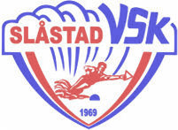
Start: 08:00

Boat: Ski Nautique

Homologation level: Ranking List

Entry fee: 1350,- NOK (3 rounds)

Deadline: 17th of August

- Entry fee must be pre-paid no later than the entry deadline
- Payment details found here: https://www.slastadvsk.com/payment-details.html
- No entry will be confirmed until payment has been received
- Refund/cancellation policy: No refund for cancellation will be given.
- Entry opens 15th April at 18.00

Training: starting from 17:00 Friday
Be ready on the dock. No excuses!!

Questions: konkurranse@vannski.info

