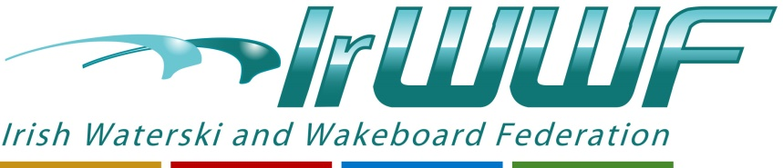

2023 National Waterski Championships

Hosted by

Golden Falls WSC

12th – 13th August 2023

Entry Form
All Division 1 (only) must enter via EMS
ems.iwwf.sport
Contact: Barry@waterskiireland.com

Name: __________________________________

e-mail: __________________________________

Club: __________________________________

D.O.B : ____/ /__________

Phone: _________________________________

License: For 2023 Season ( for 2023 the IrWWF have issued a Free Licence to all Competition entrants )
All Division 1 skiers need a EMS License:
1 Event EMS License €6.70
Unlimited competition €24.oo
IWWF

Is this your first WaterSki Competition? Y / N

Tick
Male Female

Category:
Under 10 | 35+ | 75+
Under 14 | 45+ | 80+
Under 17 | 55+ | 85+
Under 21 | 65+
Open | 70+

I (name) ______________________(Block Caps )

Consent to Golden Falls Water Ski Club and / or their agents photographing and/or videoing my involvement in Waterskiing at this Competition.

I agree that I am bound by, and to comply with, all the provisions of (i) the International Waterski and Wakeboard Federation and Sport Ireland Anti-Doping Rules, (ii) the IrWWF Anti-Doping Rules and (iii) the Sports Ireland Code of Ethics. Any failure by me to comply will result in sanctions up to disqualification from this, and subsequent IrWWF Events.

I accept that participation in the 2023 Irish Nationals is at my own risk and Golden Falls Waterski Club and/or the IrWWF cannot be held responsible for any injury sustained during my participation in this competition.

I understand that Golden Falls Waterski Club and the IrWWF will use the information provided on this form and any photographs / videos taken at this competition and may use them on Social Media posts / IrWWF Website or to contact me for competition or administrative purposes.

I understand that Golden Falls Waterski Club and the IrWWF will not pass this information onto any third party without my explicit permission, that they will process and store this information on its computers, social media, email and/or phone systems, and will retain this information for a period of seven years. At any time I can change the contact details by emailing Golden Falls Waterski Club and the IrWWF, at which time both organisations will delete my old record and replace it with new contact details provided.
I are aware that I can withdraw my consent at any time by notifying the Golden Falls Waterski Club and the IrWWF Secretary in writing, or electronically, that I wish to withdraw my consent and have my data deleted from Golden Falls Waterski Club and IrWWF systems.

Please tick the box below and sign if you agree to the above requirements / provisions.

Signed:___________________________Date / / 2023

If Under 18 Parent / Guardian / Responsible Adult Signature is required below:

Signed:____________________________Date / / 2023

Deadline for Entry: Friday 11th August

Entry Fees:
1 Event €50
2 Events €70
3 Events €100

Practice:
Fri. 11th Aug 4:00pm to 9:00pm

Slalom 4 passes €10
Tricks 6 mins €10
Jump x 3 €10

Competition
Sat. 12th Aug
Round 1 Slalom
Round 1 Tricks
Round 1 Jump

Round 2 Jump

Sun. 13th Aug
Round 2 Slalom
Round 2 Tricks

