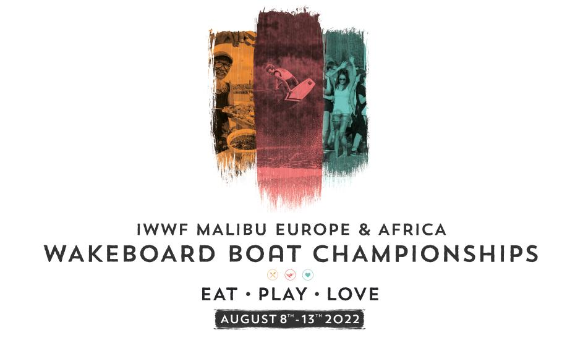

BULLETIN 2

The German Waterski & Wakeboard Federation together with the EC Wakeboard Boat Council are delighted to invite all Federations to participate in the Malibu IWWF E&A Wakeboard Boat Championships to be held from 8th to 13th August 2022 at Fühlinger See in Cologne, Germany.

Fühlinger See
Oranjehofstr. 103, 50769 Köln

WEATHER
August is usually very warm and dry. The temperature is around +30 c daytime and +20 c at night.

LOCAL CURRENCY
Local currency is Euro. Visa and MasterCard are accepted in the majority of hotels, shops and restaurants. You may need cash at small local groceries and street markets. ATM machines can be found all over the city as well as banks. Avoid exchanges currency at the airport and train/bus stations.

VISAS
Holders of European passports do not need a visa to enter Germany.
In other cases, please, check here if you do require a visa: https://www.auswaertiges-amt.de/en
If you need assistance with invitation, e-mail Sven Leichenring @ sven.leichsenring@dwwv.de

HOW TO GET THERE
There are four International airports close to Cologne: Köln-Bonn Airport (closest), Frankfurt Airport (about one hour by train to Cologne), Düsseldorf Airport (45 min. by train to Cologne), Düsseldorf (Weeze) Airport (only Ryanair, most cheap but only reachable by car in about 70 minutes).
We recommend the teams to rent cars or mini vans because it will be necessary to get around since the site is outside the city and there will be no transportation provided by Organizer.
Please, as soon as you book flights, send your details to Sven Leichenring @ sven.leichsenring@dwwv.de.
You can choose the option of renting a car for your team at the airport or take a taxi.

ACCOMMODATION
Official Hotel: Maritim, Heumarkt 20, 50667 Köln,
Phone number + 49 221 20270
Booking via telephone, codeword: EUROPEAN CHAMPIONSHIP
Link for booking: https://reservations.travelclick.com/100008?groupID=3482320&adults=1

Hotel zur Malzmühle: Alternative Hotel (right across the street)
Heumarkt 6, 50667 Köln, phone + 49 221 92160611

Thanks to the partnership with Eat Play Love specially negotiated rates have been put in place for the event:
Single €89.00 per night, includes breakfast
Double €99.00 per night, includes breakfast
Parking is available at the Hotel - Parkhouse Height 1.90m.
Parking is not included in the above rate and will be an additional cost.

Make sure to reserve rooms before 10th June 2022 at the latest. After this date - rooms are not guaranteed and will only be upon availability! A block of rooms has been reserved, at the above rates, especially for the E&A Championships so it’s strongly advised that you do not use other sites/services but make direct contact with the Hotel.

NB: Teams are responsible for organizing their own transportation between the airport and the hotel and from the official hotel to the site each day. We therefore advise all teams to rent cars or vans to get around. The Fühlinger See is approximately 20 minutes by car outside of the city.

IWWF LICENSE
Following an agreement by the IWWF World Congress held in 2019, the IWWF Executive Board approved the establishment of an IWWF License fee from 2021 where competitors of the disciplines Barefoot and Waterski the Ranking List / Record Capability competitions and for Wakeboard the 3 to 6 Stars competitions require to hold an IWWF License.
It is essential that Federations ensure that all their Wakeboard athletes hold a valid IWWF License in order to enter any E&A Confederation Championship.

INTENTION TO ENTER and ENTRY FORMS – NEW PROCEDURE FOR 2022
Countries interested in participating should submit the attached Intention to Enter form no later than 9th June 2022 to
linda.johnston@wakeboardcouncil.com
sven.leichsenring@dwwv.de

Any Federation not meeting this requirement will not be allowed to compete until they pay a fine of €250 to the IWWF.

For each participant entered on the Intention to Enter form, the Federation must pay a deposit of €50 to the Organiser - this payment is non-refundable.
This payment will ensure the number of riders participating at the event is accurate and enable the planning of the event.
If the Federation sends the number of riders as indicated in the Intention to Enter, the payment made will be deducted from the entry fee.
If the Federation sends less riders than the number indicated on the Intention to Enter, the €50 paid for each of the riders not attending will be forfeited.
The Federation may enter up to 2 additional riders more than originally declared on the Intention to Enter form.
If more than 2 additional riders participate, then a fee of €50 per additional rider will be levied on the Federation.

REGISTRATION OF RIDERS Each Federation shall register the riders through their EMS Federation Administrator no later than July 29TH 2022 (ten days before the scheduled start of the event), through the IWWF Event Management System (EMS). Any Federation not meeting this requirement will not be allowed to compete until the Federation pays a fine of US$10/€10 per rider per day after the 10-day deadline to the IWWF for each rider not officially entered. Late entries will only be accepted with the mutual consent of the Organiser and Chief judge. Registration will close 9:00 pm on August 8th 2022 (36 hours prior to the start of the competition). If a rider is not able to be at the site before the registration closes, he/she (or the Team Captain) must ensure that a digital copy of his/her passport is sent to the Chief Judge and Chief Calculator and that his/her entry fee is paid, as well as a clear indication of the division the rider will compete in.
The registration of the rider participations in EMS can be done as follows:

- The EMS Federation Administrator has to login to EMS
- Go to the Competitions menu and set the Code “22EURO06” or Country “Germany” and Discipline “Wakeboard boat” in the Search Filters
- Select the “IWWF Europe and Africa Wakeboard Boat Championship” competition
- Scroll down to the Participations section and click the “New participation” button to register the Athletes
- Enter the Name of the Athlete in the Search box and click on the loop sign to the right
- Register the Category in Competition, the Event and the Entry Type if known (if not known yet select “Individual Participant”; you must define the team members at the latest by 3:00 pm on August 9th 2022– one day prior to the first day of competition.
- Click on the blue “+Add” button and the participant will be registered
- Repeat the steps 5 to 7 for any additional participants
- Any registration after the deadline of July 29th 2022 will be put on the Waiting List to be approved by mutual consent of the Organizer and the Chief Judge
- Entry fees and penalties will be collected on site in cash

In addition to EMS registration, please send the Entry Form with a list of your riders with proper Age Categories to
Linda Johnston linda.johnston@wakeboardcouncil.com

TEAM ENTRY
A team will comprise of a maximum of 10 riders, with a maximum of 2 riders in the same category. Although it is encouraged to have a mixed participation with men and women riders within a team, it is not compulsory. Federations must nominate their team riders by 3:00 pm, one day prior to the first day of the event, after which all riders will be considered individual entries and will not contribute towards team scoring.

INDIVIDUAL RIDERS
According to the IWWF World Wakeboard Rules (rule 3.8.2) athletes who are not part of a team may compete as individuals. An individual rider's entry must be submitted through his respective Federation or Federation representative, following the same procedure.

ENTRY FEE
The entry fee is €250.00 per athlete for Open, Masters and Veterans, €200,00 per athlete for Junior categories. To be paid to IWWF EC Wakeboard Boat Council’s account.

BANK DETAILS
BANK: ABN-AMRO
PO box 59
NL – 1180 AB AMSTERDAM
Account name: Wakeboard boat Council
IBAN: NL03 ABNA 0843 8559 83
BIC: ABNANL2A

DOPING CONTROL
In accordance with the IWWF E&A Anti-Doping Rules, doping controls will be conducted during the competition. When entering this competition all athletes must agree to be subject to doping control. Information about the anti-doping rules and links to the list of banned substances can be accessed at the following link: http://iwwfed.com/athletes/anti-doping/

Here is the link to the WADA website where the Doping Control Process is explained:
https://www.wada-ama.org/en/resources/education-and-prevention/doping-control-process-for-athletes

RULES
THE IWWF World Wakeboard Boat Rules 2022 will apply.
http://iwwf.sport/wp-content/uploads/2019/03/IWWFWakeboardBoatRules2019.pdf

ELIGIBILITY
A Federation may select its team as desires according to the 2022 World Wakeboard Rules. However, each team member must be a citizen or applying for citizenships of the country that the Federation represents. In case of doubt as to the nationality of a rider the Chief Judge and the Chief Calculator normally will refer to his/her passport.

If a rider does not have a passport from the country that he/she is representing, he/she must prove residence in the country for at last five years and membership in an affiliated club of the Federation. Each Federation shall certify that all members of its team meet these qualifications.
Before taking part in the competition each rider must sign a participation contract and understand the nature of the sport and its special risks.
Riders must disclose to the event organiser any special medical conditions, including but not limited to, injuries in the past or present or other pre-existing medical conditions.

OFFICIAL FAMILIARISATION
Official Familiarisation can be booked by each Federation 15 days following the submission of the Intention to Enter forms. The number of days required for Official Familiarisation will depend on the total number of riders according to the Intention to Enter forms.
All riders will have equal time to familiarise themselves with the course and the wake.
15 days following the deadline for the intention to enter forms - booking will be available and slots will be allocated on a first come - first served basis.
Slots booked are not changeable and are not refundable.
Where required - final decisions will be made by Chief Judge and Organiser.

The price of 1 slot is €40.00 payable to EC Council account.

BANK DETAILS
BANK: ABN-AMRO
PO box 59
NL – 1180 AB AMSTERDAM
Account name: Wakeboard boat Council
IBAN: NL03 ABNA 0843 8559 83
BIC: ABNANL2A
Official Familiarisation will take place on Monday 8th and Tuesday 9th August
In order to ensure equity for all riders - each rider will have the opportunity for only 1 slot of 10 minutes.
Official Familiarisation will open for booking on 24th June 2022 at 09.00 hours CET. The process for the booking of Official Familiarisation will be strictly managed by first come first served - according to the date and time of the receipt of email requests to:
Booking by email to linda.johnston@wakeboardcouncil.com,
Maria.bulgakova@wakeboardcouncil.com

When requesting official familiarisation slots, please refer to the preferred date and if morning or afternoon is also preferred.
Slots will be attributed by order of preference as received by email date and time.
Payment must be made at the time of the confirmation of the booking and is not refundable. Slots cannot be changed following booking confirmation.

WARNING
It is vitally important that all Federations and Team Captains ensure that all riders are registered on the EMS and have purchased the IWWF licence.
All riders must be entered for the competition on the EMS no later than 29th July 2022. Clear instructions are provided above under the Registration section.

UNOFFICIAL TRAINING
The Organiser will provide the opportunity for unofficial training from Thursday 4th August.
This can be booked by directly contacting the Organiser Alex Neuwirth @ jan@eatplaylove.de

THE OFFICIAL TOW BOAT
We are delighted to announce that the exclusive Tow Boat for the 2022 E&A Championships will be provided by our official partners Malibu Boats.
The legendary Malibu 23 LSV will create the stage for the IWWF Europe and Africa Wakeboard Boat Championships this year. Athletes will experience the latest generation 23 LSV, equipped with exclusive Malibu technology developed by the Malibu engineering professionals to create the optimum wake for juniors through to the demands of the pro-athletes.
With sleek styling, the 23 LSV sets itself apart from other boats on the water, while those aboard will enjoy the comfort and luxury Malibu incorporates in each model. Both the competition boat and the support boats are equipped with the new Malibu M6Di engine.
With the perfect balance of performance, styling and luxury the 23 LSV delivers, we know this year will be an exceptional competition. We wish everyone a phenomenal time on the water.

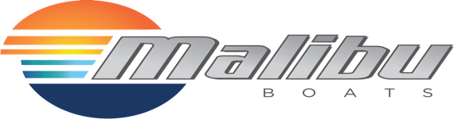

OFFICIAL OPENING and CLOSING CEREMONIES
The Opening Ceremony will be held at the event site on August 9th with a dinner to follow.
The cost of the dinner will be €25.00
The Closing Ceremony will be held at the event site on August 13th.
The cost of dinner will be advised.

FLAGS
It is important that ALL Team Captains must bring 2 flags of their country for the Opening ceremony and for the Medals ceremony. Flags should be given to the Organizer at registration.

THE OFFICIAL PANEL
Chief Judge - Stefano Duranti (ITA)
Assistant Chief Judge – Jean Phillipe Richonnier (FRA)
Judge - Rui Monteiro (POR)
Judge - Colin Hart (GBR)
Judge - Oskars Kruze (LAT)
Judge - Arnaud Jacquesson (SUI)
Judge – Nuno d’Eca (POR)

Chief Calculator – Linda Johnston (IRL)
Assistant Calculator – Maria Bulgakova (UKR)
Assistant Calculator – Erika Roch (SUI)

Chief Driver – Cyril Cornaro (SUI)
Assistant Driver – Jan Kees Speksnijder (NED)

CONTACTS
Main contact - Organiser – Alex Neuwirth & Jan Winterhoff jan@eatplaylove.de
Main contact - Federation – Sven Leichenring sven.leichsenring@dwwv.de.
Main contact – EC Wakeboard Boat Council - Linda Johnston - linda.johnston@wakeboardcouncil.com

EVENT FACEBOOK PAGE –
IWWF E&A Wakeboard Boat Championships /@WakeboardChamps/

TENTATIVE EVENT SCHEDULE (TBC)

Any day before Saturday, August 6th | Arrival of teams and officials  unofficial training starting Thursday 4th
Saturday, August 6th | Opening ceremony of Eat Play Love Festival at the site of competition
Sunday, August 7th | Last day unofficial training
Monday, August 8th | Official Familiarisation Day 1  End of registration at 21:00
Tuesday, August 9th | Official Familiarization Day 2  Opening Ceremony at the Event Site
Wednesday, August 10th | Qualification rounds
Thursday August 11th | LCQ rounds
Friday August 12th | Quarter/Semifinal rounds
Saturday August 13th | All finals day  Closing Ceremony and Medal presentation at the event site  Final party at the event site
Sunday August 14th | Music festival - Eat Play Love Festival. Day of departure

COVID-19 SITUATION
Due to the global pandemic situation a covid protocol will be in place and the necessary protection measures will be respected.

IWWF SAFE SPORT POLICY & SAFEGUARDING REGULATIONS
The IWWF takes safeguarding extremely seriously and is committed to ensuring that everyone who attends the championships, whether athletes, officials or volunteers are able to operate in a safe environment, free from abuse and the risk of harm. It is a condition of participation that all attendees familiarise themselves and comply with the IWWF Safeguarding Regulations which are available at https://iwwf.sport/safe-sport/

The MALIBU IWWF - E&A Wakeboard Boat Championships 2022

INTENTION TO ENTER FORM

The ……………………………….. FEDERATION will attend the MALIBU IWWF E&A Wakeboard Boat Championships 2022

We expect our team to consist of:

U14 Boys ___________ U14 Girls ____________
U18 Men ___________ U18 Women ___________
Open Men ___________ Open Women ___________
O30 Men ___________ O30 Women ____________
O40 Men ___________ O40 Women _____________
O50 Men ___________ O50 Women _____________

Team Captain ___________________________ Team Manager _______________________

For further information please contact ____________________________________________

Email _________________________________________phone_________________________

Date _______________________________Signature__________________________________

Please return this form by 9th June 2022 to:

linda.johnston@wakeboardcouncil.com
sven.leichsenring@dwwv.de

