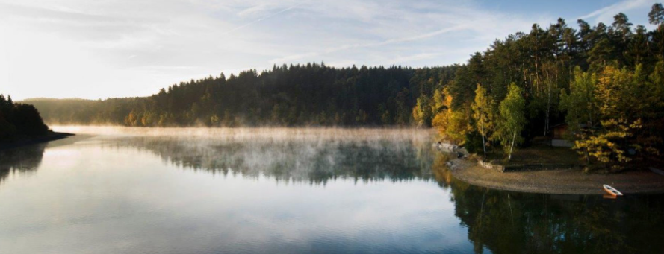

BULLETIN

SLAVOJ PLZEŇ CUP

The main competition has Ranking list homologation level. Special U12 competition has National homologation level.

GENERAL

Venue Waterski center TJ Slavoj Hracholusky lake, 15 km from Plzen direction Stříbro/Nurnberg mapa
Date 13.07. – 14.07.2024
Categories men, women
+ special competition for U 12 skiers (can compete as men/women too)
Events slalom, tricks, jump

Rounds 2 rounds in main competition, 1 round in U 12 comp.

Starting speeds men 37 km/h
women 34 km/h
U12 28 km/h

Entry conditions Registered skier in any IWWF federation + medical travel insurance for sports + IWWF License
Declared trick list for tricks.

Registration Via EMS until 9.7.2024

Entry fee - 30 € per event per skier in main competition
15 € per event per skier in U12 competition
Skier registered in Czech or Slovak federation will get discount because of the federation subvention.

Familiarization Must be ordered in advance, 2 € / min

Accommodation Individually arranged http://www.hracholusky.com/kemp/index_en.php

Food/meals Buffet on site, couple of buffets and restaurants within walking distance.

Schedule

Friday 12.7. 08:00 – 19:00 familiarization
17:00 - 19:00 registration
20:00 team captains meeting
20:30 jury meeting
Saturday 13.7. 08:30 slalom 1. round+ slalom U12
slalom 2. round
jump 1. + 2. round + tricks U12
Sunday 14.7. 08:30 tricks 1. ; 2. round

Schedule is subject to change due to weather and other circumstances.

Officials

Competition director Stanislav Eyer
Security Martin Lang

Chief judge Zdeněk Nečas (J2)
Homologator Lukáš Hořký (H1)
Scorer Hana Theer Vítková (S2)

