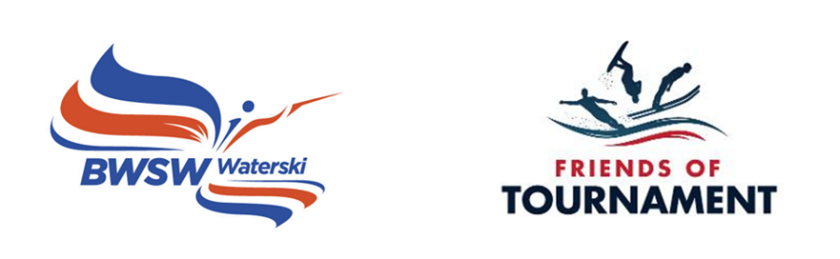
GOSFIELD DEVELOPMENT DAY BOOKING FORM, August 13th, 2024

Skier Name |  | Surname
DOB |  | Gender
Club |  | Coach
BWSW membership |  | Address
Emergency contact |  | Relationship to skier
Emergency telephone |  | Email

Please make us aware of any relevant medical information/allergies/dietary or additional needs.
Ability: Please give us the best idea of your current ability to enable us to make the Development Day as worthwhile as possible (eg; learning deep water start, would like to learn etc).

Slalom

Trick

Jump

Please confirm that you are happy to be contacted by email: Y/N
Please confirm you are happy for FoT to share photos of your child on social media: Y/N

Payment: The cost of the day is £20.00 to be paid to BWSW Friends of Tournament.
Account Name: British Waterski & Wakeboard Federation Limited
Sort Code: 30 84 23
Account Number: 25491760
Reference: surname/ event code:Gos24

Signed by parent/guardian:
Print:
Date:
FoT Supported by:

