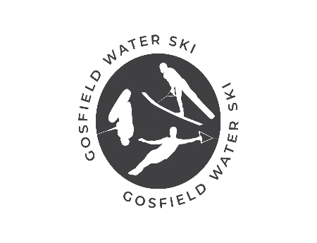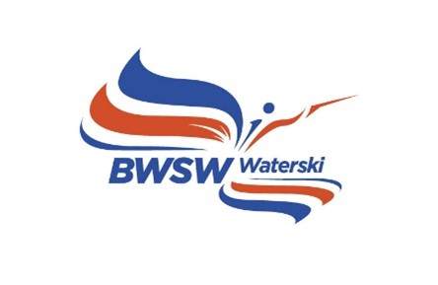

BWSW Youth Trials

British Youth Trials open to all U21 skiers.

The Site:
Gosfield Lake Resort is a private family run leisure park, set in the heart of rural Essex, close to Constable Country and right on the Essex Way. The 36-acre lake and surrounding countryside combine to create a natural beauty spot, where clear summer evenings give way to spectacular sunsets. The natural sheltering provides perfect skiing conditions, and this featured together with a full international slalom course and jump make the facilities ideal.
Directions:
Sat Nav with postcode CO9 1UD once close follow the brown leisure signs for Gosfield Lake.

Schedule
TBC
The Youth Trials consists of two rounds of Slalom, Trick and Jump, one round of each on Friday and Saturday (subject to weather conditions).

ENTRY FEES
Entry is to be made via EMS. Entry is £70 per event, discounted to £195 for all 3 events.

Payment to be made by BACS
Acc Name: Gosfield Lake Water Ski Club
S/C: 20-97-40
Acc Number: 10013714
- Please note that both a British Competitors Licence and an IWWF Licence are required.
A one off IWWF Licence can be purchased on EMS

PLEASE SEND CONFIRMATION TO emma@theturps.co.uk ONCE YOU HAVE PAID.

OFFICIAL TOWBOAT
All official practice and tournament events will be pulled behind the Ski Nautique, equipped with the latest version of Zero Off speed control.

OFFICIAL PRACTICE
This can be booked by calling 01787 475043 or emailing emma@theturps.co.uk and will be on 30th May. Practice is also available prior to the event. charged at the prevailing members rate £30.00 per set.
Once booked, sets need to be paid for either via bank or card.

COMMUNICATION
To be able to keep in touch with all the competitors we will have a WhatsApp Group so we can keep you up to date with any schedule changes, so please include a phone number with your confirmation email, if I don’t already have.

FOOD
Our onsite café, The Snack Shack at Gosfield Lake, will be open throughout the week and event. Also onsite is The Appletree restaurant, which is open wed, thurs, Fri & Sat evenings (advisable to book). In the village is The Kings Head pub which is within walking distance.

ACCOMODATION
Onsite there is the campsite electric or tents, please book direct either through gosfieldlake.co.uk or Linda 01787 475043. Both annexe apartments have already been booked. There are a lot of Airbnb in the surrounding area, along with Premier Inns and Holiday Inn.

