2023 Development Days
sponsored by
Friends of Tournament & Midlands Nautique
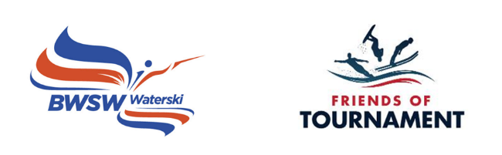

Bulletin Cotswolds 1A

Saturday 29th April 2023 Skiers briefing at 08:30, ready to ski at 09:00. Finish at 17:00.

Cotswold Water Ski Club, Lake 17, Spine Road, Cotswold Water Park, Nr Cirencester, Glos

Point of contact on the day: Meg Stowe 07511045845 or Viv Coughlan 07795477611

Please download the booking form, complete and send to: dushylukic@hotmail.com
Instructions for payment are included in the booking form.

The purpose of the day is to provide coaching to U18 Club level water skiers who would like to progress to three event skiing. It is hoped that each skier will have 4 ‘coaching sets’ lasting approximately 15 to 20 minutes each. For anyone has not previously held a BWSW Tournament Licence, this will be issued virtually after the event. We cannot provide coaching for disciplines outside of Tournament Water Skiing and places are not available for GB Squad skiers.

Friends of Tournament will organise a qualified BWSW Coach and an off water Ambassador for advice on equipment and competitive skiing generally. The Ambassador will liaise with you prior to the day regarding the boat and any other arrangements.

Coach: Glenn Campbell
Facilities: showers/ changing/ indoor/outdoor space
Food: provided for skiers and available to buy for parents/ carers
Camping: Contact Avril Neale Avril@cotswoldski.co.uk

Development Days are organised by volunteers and funded by sponsors. Friends of Tournament rely entirely on fund raising, our main initiative is The 200 Club, a small lottery. The details of this can be found on our website: http://www.tournamentwaterskiing.org.uk/200-club/

