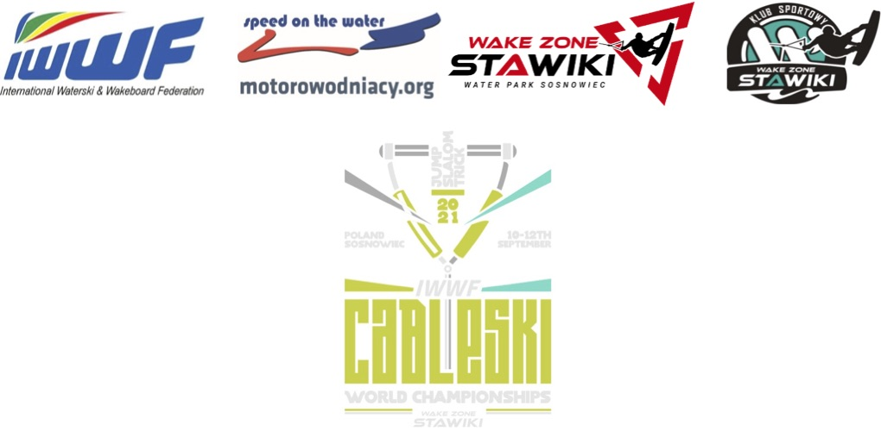

Intention to Enter

The Federation intend to participate in the 2021 IWWF Cableski World Championships

Our Team will consist of:

 | Male | Female
Number of Open Skiers:
Number of Officials:

Contact Details for future information of this IWWF World Championships:

Name:
Function:
Address:
Telephone Home:
Telephone Mobile:
Fax:
E-Mail:
Please send the Intention to Enter before 13th July 2021 via E-Mail to: Organization Team
Aleksandra Gogola: ola@wake-zone.pl &
IWWF World Cableski Council Chairman Martin Graw: martin.graw@web.de

