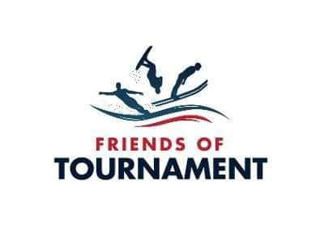
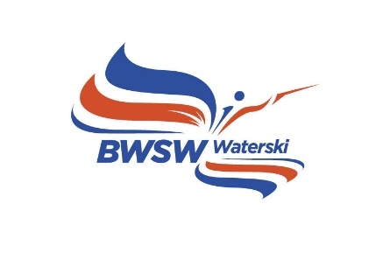

BRITISH WATERSKI NATIONALS 2023 SKIER PROFILE
First Name:
Surname:
Nickname, if any:
Date of birth:
Age at Time of the Nationals:
Category in which competing:
Events Entered (please delete as appropriate): SLALOM TRICKS JUMP OVERALL
Specialism/favourite event:
Club/training sites:
Coach, if relevant:
Home town/county:
School/uni attended/work:
Competition PBs and when achieved:
Best practice scores in 2023:
Previous appearances at British Nationals and best results:
Major achievements/titles etc:
Family connections in waterskiing:
Sponsors?:
Other hobbies/sports:
Anything else of interest about you:
Make & Model of Ski and Length:
Prefered Zero Off setting:
Which Foot Forward:
Favorite Towboat:
Date this profile was completed
Please email profile to Jane@bwsf.co.uk

