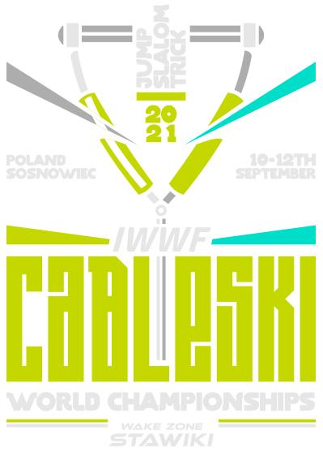

2021 IWWF Cableski World Championships
10th – 12th September 2021

Wake Zone Stawiki, Sosnowiec
Poland
Bulletin #2*
*all changes & additional information to Bulletin #1 are marked/noted in green
The Polish Motorboat and Water Ski Association, Klub Sportowy Wake Zone Stawiki and the Wake Zone Stawiki Water Park Sosnowiec herewith invite all Members of IWWF Affiliated Federations to the 2021 IWWF Cableski World Championships which will be held in Sosnowiec, Poland from 10th to 12th September 2021.

- LOCATION & TRAVEL
The city of Sosnowiec is situated in southern Poland. The location of our cable offers convenient access from the Katowice International Airport (27km) and from the John Paul II International Airport Kraków-Balice (67km). One could use the highly dependable European rail network to get to either Katowice or Sosnowiec. Also, numerous bus and tram lines make travelling through the cities of the Silesian Metropolis hassle-free.

For train schedules: http://mt.rozklad-pkp.pl/en

- INTERNATIONAL TRAVEL (COVID-19 RELATED REQIREMENTS)

All participants travelling to Poland, should take note of the following guidelines and requirements: https://www.gov.pl/web/coronavirus/temporary-limitations

It is each individual participant’s responsibility to be up to date with the requirements of entering and leaving Poland and returning to their own country.

A medical provider will be on-site on 11th September (Saturday) providing polymerase chain reaction (PCR) tests if you need testing to return to your respective countries. The cost of the testing is to be covered by each participant.

PRICE: 249 PLN (payment by card only)

- COMPETITION SITE
Wake Zone Stawiki Waterpark Sosnowiec
Jana Sobieskiego 49 Street
41- 200 Sosnowiec
- ORGANIZER CONTACT
Aleksandra Gogola
Business Manager
Phone: +48 786 236 666 (whatsapp available)

Email: ola@wake-zone.pl

http://www.wake-zone.pl
https://web.facebook.com/wakezonestawiki/

- OFFCIAL WEBSITE
https://iwwf.sport/cableskiworlds2021/
- CABLE SYSTEM
- RIXEN 5.0 Cable built in 2017:
- LENGTH 749m
- HEIGHT 11m
- COUNTER-CLOCKWISE
- 10 CARRIERS

The competition will run according the 2020 IWWF Cableski Technical Rules in the latest Version.
- ACCOMODATION
Hotel name | Holiday Inn Dąbrowa Górnicza
Address | Aleja Róż 1A, 41-300 Dąbrowa Górnicza
Phone | +48 32 755 00 00 Reception, +48 885 987 105 A. Szczyra
Contact Person | Agnieszka Szczyra
Email for booking | reservation@hidabrowa.pl  please use code: WAKE ZONE STAWIKI when booking the rooms for preferred rates.
Rate single | 269 PLN standard DBL/TWIN room for single occupancy including breakfast
Rate double/twin | 309 PLN standard  DBL/TWIN room for two people including breakfast
Credit Cards | American Express, Visa, MasterCard
Hotel Website | https://www.holidayinn.com
Distance from Site | 9 km (approx. 15 mins drive)
Notes | Kids ages 17 and under stay for free when sharing their parents’ room. Up to four kids ages 12 and under eat free any time of the day in any Holiday Inn® on-site restaurant.  View Terms & Conditions for Details at the Hotel website.

- HOW TO REACH HOTEL AND THE SITE
The Organizer will arrange transportation between the Official Hotel and Wake Zone Stawiki Waterpark during the event for athletes and Team Officials at regular intervals (to be posted up on the official notice board).
Possible transport options (airport transfers, transport between Official Hotel and the site for trainings, other commute etc.):
- Transfers booked with the hotel
- Taxi
- Taxi Apps: Uber, Bolt
- Car / bus rental
Transportation from and to the airport will be offered free of charge to Executive Board Members, Technical Officials and IWWF Cableski Council Members.
Official transportation schedule for Executive Board Members, Technical Officials and IWWF Cableski Council Members will be announced upon the official schedule of the Bureau Meeting and Executive Board Meeting and will be available on the competition website as well as the information board in the Official Hotel.
Airport transfers booked with the Official Hotel for Athletes and Team Officials:
Katowice Airport (KTW) – Hotel
Car – 120 PLN
Bus (8 people) – 150 PLN
Kraków Airport (KRK) – Hotel
Car – 300 PLN
Bus (8 people) – 350 PLN
Warsaw Airport (WAW) – Hotel
Car – 950 PLN
Bus (8 people) – 1100 PLN
*All the rates are for one-way journey and arrangements should be made directly with the Official Hotel.
- CURRENCY
PLN /Polish Zloty/ is used in Poland and all major credit cards are accepted almost everywhere. Close to the hotel and the site you can find banks and ATMs.
- VISA REQUIREMENTS
Please check entry requirements for your country or contact Polish Embassy in your country.
- OFFICIAL TEAM TRAINING
Official Team Trainings will take place on Friday 10.09.2021 from 09:00 – 13:00. Detailed plan to be announced.
- UNOFFICIAL FAMILIARIZATION
Available any time before the official start of the Championships.
Prices:
- During the season (until 31st August): EUR 120/h

- From 1st September to the official start of the Championships: EUR 160/h*. Minimum slot to book is 30 min for EUR 100.
*for the Teams that book an accommodation in the Official Hotel: EUR 150/h.
The course will be cleared from obstacles from 1st September (until then the course will be adjusted to trainings).
Please send your training requests to ola@wake-zone.pl.
The training schedule will be available by 10th August 2021. If you want to book trainings earlier, please contact ola@wake-zone.pl.
The schedule will be sent via email for the review and approval.
The payment for unofficial practice to be made on-site.
Please be aware that changes in final practice schedule may occur due to homologation process and in accordance to provide the time slots to the countries balanced and equally.
- COMPETITION SCHEDULE
Thursday 9th September |  | Last Practice for Teams untill 17:30
 | 09:00-17:00 | Registration of teams and Skiers
 | 13:00-16:00 | IWWF Cableski Council Meeting
 | 16:00-18:00 | Homologation (all day)
 | 16:30-17:30 | Skiers Meeting --> Skiers rep
 | 18:00-20:00 | Homologation on water
Friday 10th September | 6:00- 9:00 | Homologation (Reserve)
 | 9:00-13:00 | Official Training
 | 13:00-13:30 | Judges meeting
 | 13:30-14:00 | Team Captains meeting
 | 14:30-17:30 | Tricks preliminary round: women and men
 | 18:30-20:00 | Opening ceremony
Saturday 11th September | 8:00-12:00 | Slalom preliminary round: women and men
 | 13:30-16:00 | Jump preliminary round: 150, 165, 180, women and men
Sunday 12th September | 08:00-09:30 | trick final: women and men
 | 10:00-12:30 | Slalom final: women and men
 | 13:00-13:30 | Medal ceremony for tricks and slalom.
 | 14:00-16:00 | Jump final: women and men
 | 16:30-17:00 | Medal ceremony for Jumps
 | 20:00 - | Closing ceremony and medal ceremony for overall and team classifications.

- LUNCHES, DINNER, FINAL NIGHT BANQUET
Lunches will be provided on site for athletes + one non-competing team member and officials during days of competition.
During other days and for evening meals it will be possible to arrange yourself in the city as both Hotel and the site are situated in the close range to few cities in Silesian Metropolis with lots of restaurants, cafes and supermarkets around.
Opening Ceremony and Final Night Banquet are free of charge to Athletes, Team Officials, Technical Officials, Executive Board members and IWWF Cableski Council members.
Cost for Non-Invited Personnel to Attend Final Awards Ceremony Dinner: 30 EUR
INTENTION TO ENTER
In accordance with IWWF Rule 2.05, each Federation is required to submit an Intention to Enter for the Championships.
Each Federation shall certify to the Chairman of the IWWF Cableski Council and to the organizing committee, not later than 60 days before the scheduled start of the familiarization of the IWWF Cableski World Championships, it’s intent to compete. Any Federation not meeting this requirement will not be allowed to compete until they pay a fine of EUR 200 to the IWWF.
Submission deadline: 13th July 2021.
Please find the form in Word format under the official website: https://iwwf.sport/cableskiworlds2021/

- ENTRY FEE
The Entry Fee is EUR 250 per skier regardless of the number of disciplines. This amount includes a US$30 levy which will assist technical officials with their travel costs. Entry fee to be paid during the registration on-site.
- PAYMENT DETAILS (Entries, Trainings, Banquet)
Please, request for an invoice from the Organizer and ensure you correctly state the invoice number when making payment. Note, payments WITHOUT an invoice number may not be recognized by recipient.

EUR
Beneficiary: AKADEMIA SPORTU STAWIKI SP. Z O.O.
Address: JANA SOBIESKIEGO 49, 41-200 SOSNOWIEC
Account No.: 53 1140 2004 0000 3412 1243 7036
Bank of beneficiary: MBANK
Kod BIC Swift: BREXPLPWMBK

IMPORTANT – Federations are responsible for ALL bank charges
- FINAL ENTRY
In accordance with IWWF Rule 2.05, each Federation is required to submit an Official Entry Form for the Championships.
Any Federation shall certify to the Chairman of the IWWF Cableski Council, the Chairman of the Confederation Cableski Council, and the organizing committee, not later than 15 days before the scheduled start of familiarization of the IWWF Cableski World Championships, the names of the members of its team, the events each will enter, the ratings of each skier, as well as the names of the official reserves. Any Federation not meeting this requirements will not be allowed to compete until the Federation pays a fine of EUR 10 per skier per day after the 15-day deadline to the IWWF for each skier not officially entered.
Submission deadline: 27th August 2021.
Please find the form in Word format under the official website: https://iwwf.sport/cableskiworlds2021/

- OFFICIALS PANEL
Chief Judge | Marie-Anne | Persoons | BEL
Assistant Chief Judge | TBD | TBD | POL
Homologator | Bernward | Stamm | GER
Chief Scorer | Horst | Heinicke | GER
Assistant Scorer | Tali | Menzon | ISR
Chief Operation Officer | Markus | Hörnschemeyer | GER
Assistant Operation Officer | Maoz | Tal | ISR
Event Judge | Elena | Kunert | SVK
Event Judge | Martin | Graw | GER
Event Judge | Luidmila | Mikhanovic | BLR
Event Judge | Roi | Lichtman | ISR
Event Judge | Elke | Ehlmann | GER
Event Judge | Alexandr | Isaev | BLR
Jury & Officials: please contact Aleksandra Gogola at ola@wake-zone.pl to arrange Hotel reservations and airport transfers.
- DOPING CONTROL
In accordance with the IWWF Anti-Doping Rules, doping controls will be conducted during the competition. By entering this competition, all athletes agree to be subject to doping control.
Information about the IWWF Anti-Doping program, the current IWWF AD Rules and links to the list of banned substances can be accessed on the following link http://iwwf.sport/athletes/anti-doping/
- COVID-19 BASIC PREVENTIONS
The following protocols are recommended:
Detailed COVID-19 prevention guidelines will be announced as a separate document.
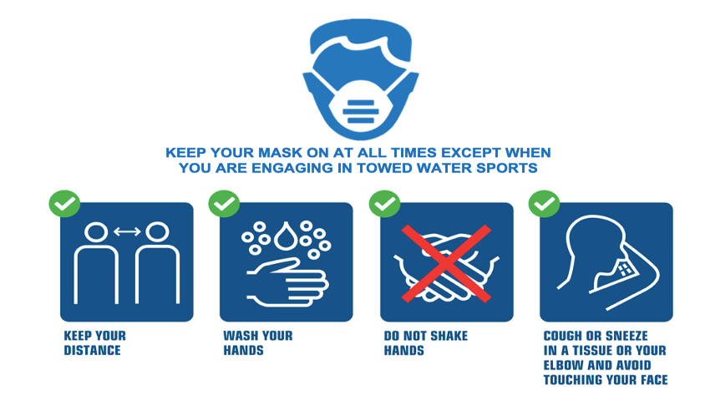
- IWWF SAFE SPORT POLICY & SAFEGUARDING REGULATIONS
The IWWF takes safeguarding extremely seriously and is committed to ensuring that everyone who attends the championships, whether athletes, officials or volunteers are able to operate in a safe environment, free from abuse and the risk of harm.

It is a condition of participation that all attendees familiarise themselves and comply with the IWWF Safeguarding Regulations which are available at https://iwwf.sport/safe-sport/
- ADDITIONAL INFORMATION
- Power outlets

Details of voltage and electrical socket types in Poland can be found at the following link: https://www.power-plugs-sockets.com/poland/

- SIM cards

Poland offers several choices when it comes to buying a SIM card, with four main cell networks to choose from: Orange, Play, Plus, and T-Mobile.

There are many ways to buy SIM cards and packages: in supermarkets, street kiosks, gas (petrol) stations, and official company stores. It is mandatory to register with your passport or national ID card when buying a SIM card in Poland, due to an anti-terrorism act that went into effect around July 2016.

You can easily buy top-up vouchers in the same places you bought the SIM card, including street kiosks, stores, petrol stations, or online.

- Attractions & Restaurants

https://www.inyourpocket.com/katowice/silesian-tourism-organisation_153687v

- Shopping

Silesia City Center, Katowice - http://www.silesiacitycenter.com.pl/?lang=en

Galeria Katowicka, Katowice - https://galeriakatowicka.eu/en/

Designer Outlet Sosnowiec, Sosnowiec- https://www.designeroutletsosnowiec.pl/en/

Galeria Libero, Katowice- https://liberokatowice.pl/en/

LOOKING FORWARD TO SEE YOU IN SOSNOWIEC!
Please inform us about your participation as soon as possible.
And if you need help, please feel free to contact us!

