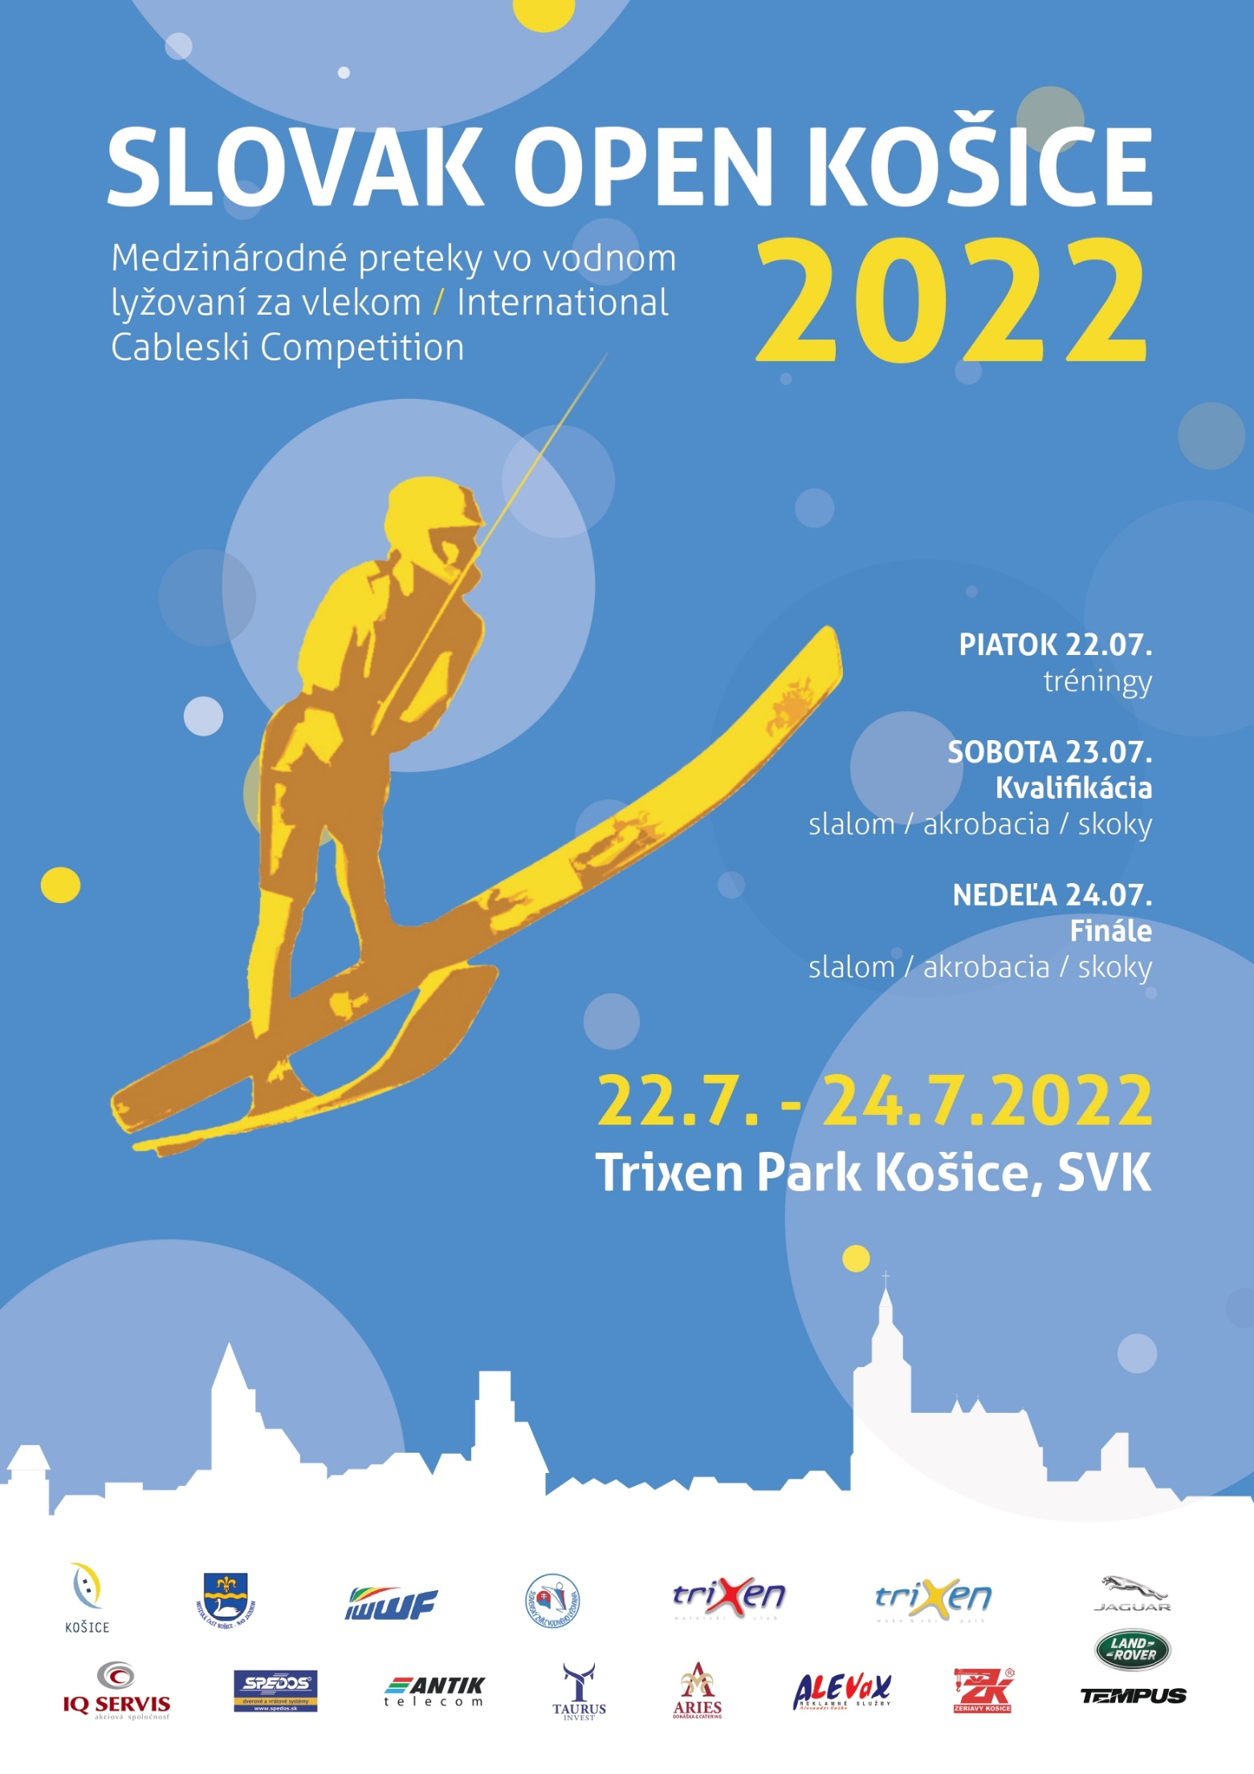

The Slovak Water Ski & Wakeboard Federation and Water Ski Club TRIXEN invites you to the Slovak Open Kosice 2022, which will be held on 22nd of July until 24th of July 2022 at Kosice.

COVID - 19:
Please observe the current epidemiological situation and conditions for foreigners entering the territory of the Slovak Republic on this website:
https://korona.gov.sk/en/travel-to-the-slovak-republic-traffic-light-system/

1. Venue and Organizer:
"TRIXEN PARK KOSICE" - sidlisko Nad Jazerom, Kosice

KVL TRIXEN, www.trixen.sk
Alexander Vaško, e-mail: vasko@iqservis.sk, telephone contact: +421 903 623 112

2. Conditions of the Competition:
The competition will be held at the Cableway in Košice /Slovak Republic
Events: Tricks, Slalom, Jump
Rules: The competition will be held according to the IWWF Cableski Technical Rules 2022.

3. Categories:
The competition will be carried out in the following Categories:
Open Men and Open Women, Junior Boys and Girls U19, Junior Boys and Girls U15, Senior Men

4. Homologation:
This competition will be held in Record homologated for Slalom, Jump and Tricks.

5. Drawing facility:
RIXEN Cableway (4 pulleys)/Direct drive

6. Judges
You can find on official cable ski website.

7. Entry fee, conditions:
*The organizer collects an entry fee as follow
Open and senior class / 110.00 € for 3 events per skier and 60.00 € for each single event.
U15 and U19 class / 70.00 € for 3 events per skier and 45.00 € for each single event.

*The entry fee must be paid in Euro in the competition office before training starts.

*International insurance with risk for sports on training and competition days

*The unofficial training 1 hour / 170,00 € / reservation: vasko@iqservis.sk

8. Provisional Time schedule:

Wednesday 20 July, Thursday 21 July
Practice possibilities for teams

Friday 22 July Practice possibilities for teams

16:00 - 18:00 Accreditation of the participants
18:15 - 20:00 Official training (1 round/per skier/per disciplines)
18:00 Captain and Judges meeting

Saturday 23 July 08:30 Preliminary slalom all categories
following Preliminary tricks all categories
following Preliminary jumps all categories

Sunday 24 July 09:00 Finals U15 and U19 categories
12:00 Final Open categories

The time schedule can be altered by decision of the judges and organizer due to the number of participants entered for the different categories.

9. Registration:
The entry form of the participants must be available latest 22nd of July 2022 to the organizer.
e-mail: vasko@iqservis.sk

10. Prize Money:
Will be announced soon.

11. Liability:
In entering this competition, the competitors will agree to abide by the rules of the IWWF / EAME or additions there to which may be in force by the time.
The organizing club does not undertake any liability for damage to persons, material or property against competitors, Technical Official (TO), judges, official helpers and other persons.
All competitors take part on their own risk in every respect even if they are engaged out of the competition, e.g. in any additional program. With the entry of the competition they give up any claim
from cases of loss of any kind arising indirectly or directly during this event. Actives ought to have affected a private accident insurance besides their health insurance. Damage to a third party (e.g. spectators) is insured only within the limits of the organizer’s liability.

12. Accommodations:

Participants have to take care of accommodation by themselves.

https://www.megaubytovanie.sk/apartmany-kukucin#price-list

Route E58 - Camp Košice
www.camp-kosice.sk

Penzion Šport
www.penzionsport.sk

*before it was Autocamping Salas.

https://www.travelguide.sk/svk/kosice/ubytovanie/turisticke-regiony/
www.booking.com
www.trivago.cz

We are looking forward to your participation.

On behalf of the Slovak Waterski & Wakeboard Federation and Water ski club TRIXEN
Alexander Vaško

